

ASSIGNMENT COVER SHEET

**Lecturer’s Name:**  Ruth Lennon

**Assessment Title:**  IaC Mini Network

**Work to be submitted to:**  Ruth Lennon

**Date for submission of work:**  <<14/11/2023>>

**Place and time for submitting work:**  Blackboard

To be completed by the Student

**Student’s Name:**  Jolly Kannampuzha Joy Lno: L00179085

**Class:**  DevOps

**Subject/Module:**  IaC

**Word Count (where applicable):**  N/A

**I confirm that the work submitted has been produced solely through my own efforts.**

**Student’s signature:**  Jolly Kannampuzha Joy **Date:**  <<14/11/2023>>

# Conclusion:

The purpose of this assignment is to learn about the usage of AWS services in the context of Infrastructure as Code (IaC). It involves understanding the use of .yaml files, editing them using the designer, and uploading them via AWS CloudShell. This is also a replication of mini network. Here we could see the cloud formation Stack is created using .yaml files. (AWS, n.d.) When you create key pairs in AWS, they consist of a private key and a public key that serve as security identities when relating to EC2 instances. Amazon Elastic Compute Cloud stores the public-key on the instance. Using the privat-key, you can securely SSH into a Linux system.

In this mini network, (AWS, n.d.) resources like virtual private cloud, jump box, web servers, Database etc were created using .yaml file. The usage of designer and submission of yaml file done through CloudFormation UI to understand how could do setup. It was quite challenging and references made when try the .yaml file uploads and creation of stacks. Setups done in figure 2. The code written were reused with changing the configurations of IP range, availability zones and ami images for instances.

There are some import value functions is used to import vale from another stack since resources as created. Fn::ImportValue.

There is one virtual private cloud is created with id VPCId, one RDS and three EC2 instances. There are Master CIDR block of IP-address e.g., 10.0.0.X/16 is used with the correlation with real concept that which could assign the more IP addresses. In order for network routers to effectively route data packets to the appropriate device, they must be able to determine the correct subnet based on the given information. Subnet-address e.g 10.0.X.0/24 where X=0,1,2,3,4

Another thing like as per usability point of, I have divided the .yaml file to 5 and created separately. So that it was easy to do stage wise approach to correct the file errors and proceed the mini network build ups. Like first I have tried VPC and first instances in stage 1, next F instance along with stage 1, then adding instance A along with stage 2 and finally Instance D along with stage 3. It helped to create as each stack and troubleshoot when file had issues while upload also while performing scripts. Also, there is high level of reusability since each stack is written as single unit and could be used if more such kind of machine to get provisioned just making small changes around subnet. (AWS, n.d.) Stack is configured using parameter.json so that it can be made reusable. For example, parameter values are given in json so that it’s easy to make changes and reupload rather than .yaml file edits. Another example is that dependency between the resource across stack is managed through use of import and export capability offered by AWS. As per references, improvements could be done by creating single subnet.yml to create and add public and private subnet references.

In IaC, the main importance is that the infrastructure to be configured in cost effective and secure way. E.g., Authentication and authorization. Only public subnet needs to be publicly accessible, while private network only be accessible with only respective config. For example, Instance1 i.e. jump box could be publicly accessible while instance F and instance A is accessible through Instance A. Instance D is made available to J only through via instance A While F and A are in private subnets have security Groups configured. The DB instance D is made available to J through A.

The (The PostgreSQL Global Development Group, n.d.) DB instance supports various relational dbs e.g Postgres, SQL Server, MySQL and MariaDB. In this we have used Postgres as relational database.

There is NAT Gateway used which could make the internet available in private instance. By using NAT Gateway rather than internet Gateway, so that we can restrict the inbound traffic. Ami images we can use differently as we have ami images we have, I have used ami image on which installed ngnix through internet via NAT Gateway. I understand there are already ami already installed with (UserGuide_AMIs.html, n.d.)ngnis available since AWS community encourages the third-party contributions so that any individual can create ami images and make it for public usage.

Even though creating a resource through AWS is simple when compared to a group of resources as that need planning and technical view of implementation in cost effective manner. Here private and public network used with to handle security. Private subnets are in same configurations, except NATGateway. CloudFormation templates are used which helps to reusability of template, so that these configurable. It could have done better way if we choose (AWS, n.d.) nested stacks to combine multiple stacks.

In mini project, VPC is created. Then public, private subnet created under VPC. After that jump box (Instnace1) EC2 resource is created under public subnet. Then tried to create Web Hosting server (Instance F) connected to Instance1. Created Application Sever EC2 instance in private subnet. Then DB server (Instance D) under private subnet. Allowed rules to connect Jump box to Application server, Web Server and DB Server via App Server. Also added Security for each group. jump_box to connect via ssh to the instances in the private subnet. Two subnet mask is used for RDS, with the concept that two availability Zone are considered here.

Using template, specific resources created with standards and naming conventions. Risk point of view, ingress and egress rules help to restrict unauthorised access. Moreover, template is the usage for standardised way even if takes review and modification according to compliant standards. From the CloudFormation, it is great way to automate activities for the resource creation. Even though it can be done using AWS UI quickly, the profits by writing a cloud formation are good if you think the reusability across team and groups.

# References

AWS. (n.d.). *cloudformation-vpc-template*. Retrieved 11 11, 2023, from https://docs.aws.amazon.com/codebuild/latest/userguide/cloudformation-vpc-template.html

AWS. (n.d.). *Create key pairs*. Retrieved 11 11, 2023, from docs.aws.amazon.com: https://docs.aws.amazon.com/AWSEC2/latest/UserGuide/create-key-pairs.html

AWS. (n.d.). *create-stack*. Retrieved 11 11, 2023, from aws cloudformation create-stack

The PostgreSQL Global Development Group. (n.d.). Retrieved 11 11, 2023, from https://www.postgresql.org/download/linux/debian/

*UserGuide_AMIs.html*. (n.d.). Retrieved 11 11, 2023, from https://docs.aws.amazon.com/AWSEC2/latest/UserGuide/AMIs.html

# Appendix

|  |  |  |
| --- | --- | --- |
| Resource | Description | .yml ,json reference |
| VPC | Resource Type VPC | VPC.yml |
| demoGateway1 | Internet gateway | InstanceA.yml ,  InstanceA-paramters.json |
| NATGateway | NAT gateway; placed in demoSubnetL1 | InstanceA.yml |
| EIP | Elastic IP associated to the NAT gateway | InstanceA.yml |
| demoSubnetL1 | public subnet for instance J | InstanceF-paramters.json |
| Subnet | private subnet for instance F | InstanceF.yml |
| demoSubnetL1 | private subnet for instance A | InstanceA-paramters.json |
| Subnet1 | first private subnet for DB instance D | InstanceD.yml |
| Subnet2 | second private subnet for DB instance D | InstanceD.yml |
| demoDBSubnetGroup | Subnet group for DB instance | InstanceD.yml |
| SecurityGroup | security group for instance J | InstanceJ.yml |
| SecurityGroup | security group for instance F; ideally to allow only comms from J | InstanceF.yml |
| SecurityGroup | security group for instance A; Ideally to allow only comms from F | InstanceA.yml |
| SecurityGroup | security group for DB instance D; Ideally to allow only comms from A | Instance.yml |
| Instance1 | Jumpbox; public facing ubuntu OS | Instance1.yml |
| F | A web Hosting server; private instance | InstanceF.yml |
| A | App web server with nginx; private instance | InstanceA.yml |
| D | DBInstance with PostgreSql | InstanceD.yml |

Table List of resources created

|  |  |  |  |  |
| --- | --- | --- | --- | --- |
| VPC | Instance1 (J) | InstanceF | InstanceA | InstanceD |
| CidrBlock:  10.0.0.0/16 | "10.0.0.0/24" | "10.0.1.0/24" | "10.0.2.0/24" | "10.0.3.0/24"  "10.0.4.0/24" |
| SecurityGroupIngress: | - IpProtocol: tcp            FromPort: 80    #webpage browser host            ToPort: 80            CidrIp: "10.0.0.0/0"          - IpProtocol: tcp            FromPort: 22  #ssh connection port            ToPort: 22            CidrIp: "0.0.0.0/0"   # later 10.0.0.0/24  ---only jump box | - IpProtocol: tcp            FromPort: 80    #webpage browser host            ToPort: 80            CidrIp: "10.0.0.0/0"          - IpProtocol: tcp            FromPort: 22  #ssh connection port            ToPort: 22            CidrIp: "10.0.0.0/0" | SecurityGroupIngress:          - IpProtocol: tcp            FromPort: 80    #webpage browser host            ToPort: 80            CidrIp: "10.0.0.0/0"          - IpProtocol: tcp            FromPort: 22  #ssh connection port            ToPort: 22            CidrIp: "10.0.0.0/0" | SecurityGroupIngress:          - IpProtocol: tcp            FromPort: 5432            ToPort: 5432            CidrIp: "0.0.0.0/0 |
| SecurityGroupEgress: | SecurityGroupEgress:          - IpProtocol: tcp            FromPort: 80            ToPort: 80            CidrIp: "10.0.0.0/0"          - IpProtocol: tcp            FromPort: 22  #ssh connection port            ToPort: 22            CidrIp: "10.0.1.0/24"          - IpProtocol: tcp            FromPort: 22  #ssh connection port            ToPort: 22            CidrIp: "10.0.2.0/24"          - IpProtocol: tcp            FromPort: 443            ToPort: 443            CidrIp: "0.0.0.0/0" | IpProtocol: tcp            FromPort: 80            ToPort: 80            CidrIp: "10.0.0.0/0" | SecurityGroupEgress:          - IpProtocol: tcp            FromPort: 22  #ssh connection port            ToPort: 22            CidrIp: "0.0.0.0/0"          - IpProtocol: tcp            FromPort: 80   #webpage browser host            ToPort: 80            CidrIp: "0.0.0.0/0"          - IpProtocol: tcp            FromPort: 5432            ToPort: 5432            CidrIp: "0.0.0.0/0"          - IpProtocol: tcp            FromPort: 443  #https            ToPort: 443            CidrIp: "0.0.0.0/0" |  |
| Improvement 1:  Control outbound |  |  | #<ideally below needed to control outbound>      #   - IpProtocol: tcp      #     FromPort: 5432      #     ToPort: 5432      #     CidrIp: "10.0.3.0/0"      #   - IpProtocol: tcp      #     FromPort: 5432       #     ToPort: 5432       #     CidrIp: "10.0.4.0/0" |  |
| Improvement 2: Parameterisation |  | Parameterisation in json file | parameterisation in json file | parameterisation in json file |
| Improvement 3: NATGateway |  |  |  | NATGatewayRoute:  DestinationCidrBlock: 0.0.0.0/0 |
| Improvemen 4: AvailabilityZone | AvailabilityZone: eu-north-1a  AvailabilityZone | AvailabilityZone: eu-north-1a | AvailabilityZone: eu-north-1a  AvailabilityZone | AvailabilityZone: eu-north-1c  AvailabilityZone: eu-north-1a |
| Improvement 5: use of json |  |  |  | MasterUsername: !Ref DBUsername        MasterUserPassword: !Ref DBPassword |
| Improvement 6: use of export function | outputs:    demoVPC1:      Description: Top level VPC Id      Value:        Ref: demoVPC1      Export:        Name: !Ref VPCId |  |  |  |
| Improvement 7: use of SSM |  |  |  | "ParameterKey": "DBPassword",          "ParameterValue": "{{resolve:ssm-secure:DBPassword}}" |

Table List of inbound and outbound , Improvements

|  |  |  |
| --- | --- | --- |
| Parameters | Description | VPC |
| VPCId | Name of VPC Id Output. It is variable exported to output and used in the stacks like each of Subnets that requires the VPCId | demoVPC1ID |
| GatewayId | Name of Gateway Id Output. This variable is also exported to output so that it can be used in other stacks | demoGatewayID |

Table Parameters in VPC.yml

|  |  |  |  |
| --- | --- | --- | --- |
| Parameters | Description |  | D Intsnace |
| VPCId | Name of VPC Id from Output | | demoVPC1ID |
| InstanceName | Name of the db instance | | demoSecurityGroup |
| DBInstanceIdentifier | db instance identifier | | demoDBInstanceIdentifier |
| VPCSecurityGroupsName | Name of the variable for security group | | demoSecurityGroup |
| DBUsername | username of the db | | {{resolve:ssm-secure:DBUsername}} |
| DBPassword | Password of the db | | {{resolve:ssm-secure:DBPassword}} |
| DBSubnetGroupName | Subnet group's name | | demoDBSubnetGroup |
| DBSubnetGroupDescription | Subnet group's description | | DB Subnet for RDS |
| Subnet1 | First subnet Id |  | Subnet1 |
| Subnet2 | Second subnet Id | | Subnet2 |

Table parameters in InstanceD.yml

|  |
| --- |
| aws cloudformation create-stack --stack-name VPC --template-body <file://VPC.yml>  aws cloudformation create-stack --stack-name SubnetL1 --template-body file://Instance1.yml --parameters <file://Instance1-parameters.json>  aws cloudformation createf-stack --stack-name SubnetLF --template-body file://InstanceF.yml --parameters <file://InstanceF-parameters.json>  aws cloudformation createf-stack --stack-name SubnetLA --template-body file://InstanceA.yml --parameters <file://InstanceA-parameters.json>  aws cloudformation create-stack --stack-name SubnetD --template-body file://InstanceD.yml --parameters <file://InstanceD-parameters.json> |

Table AWS ClousShell scripts

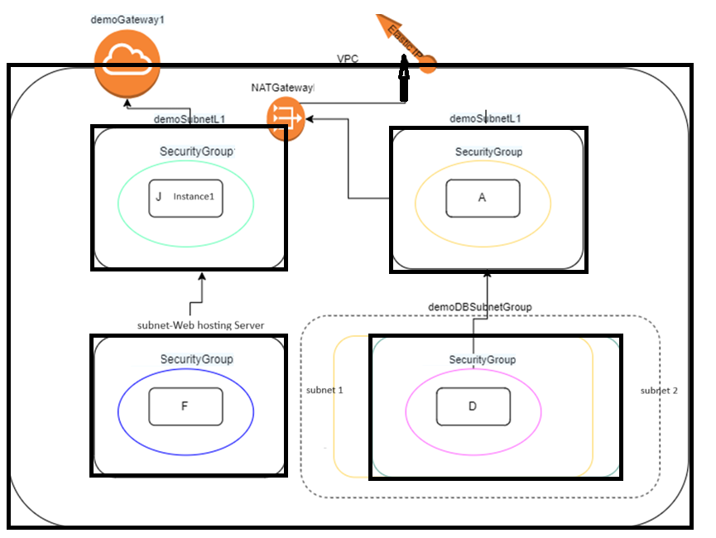

Figure Diagram of Mini Network implementation

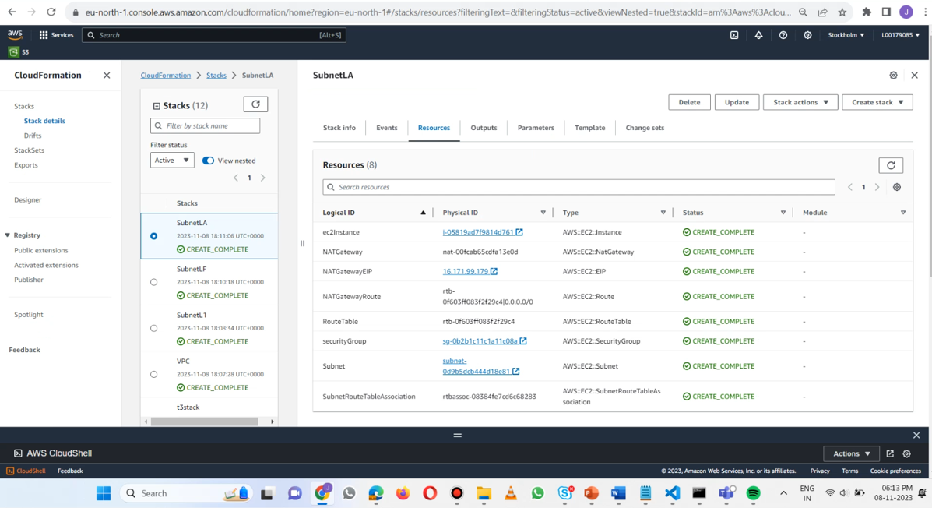

Figure Stack > creation

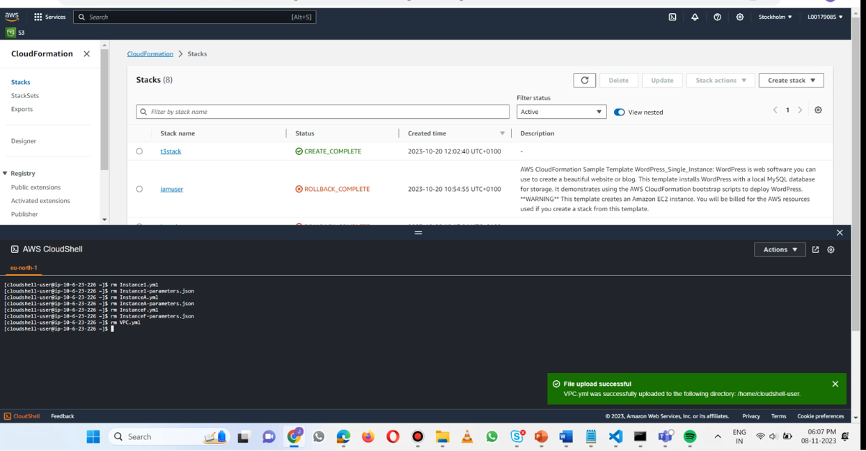

Figure VPC.yml > uploaded

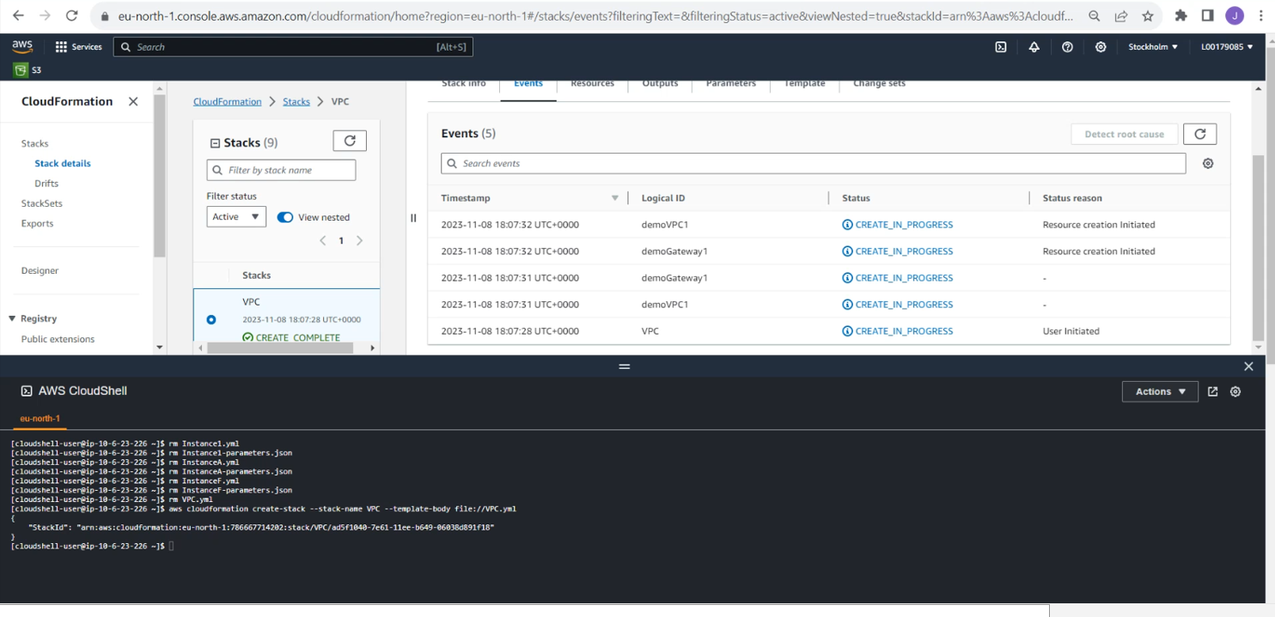

Figure VPC.yml > creation

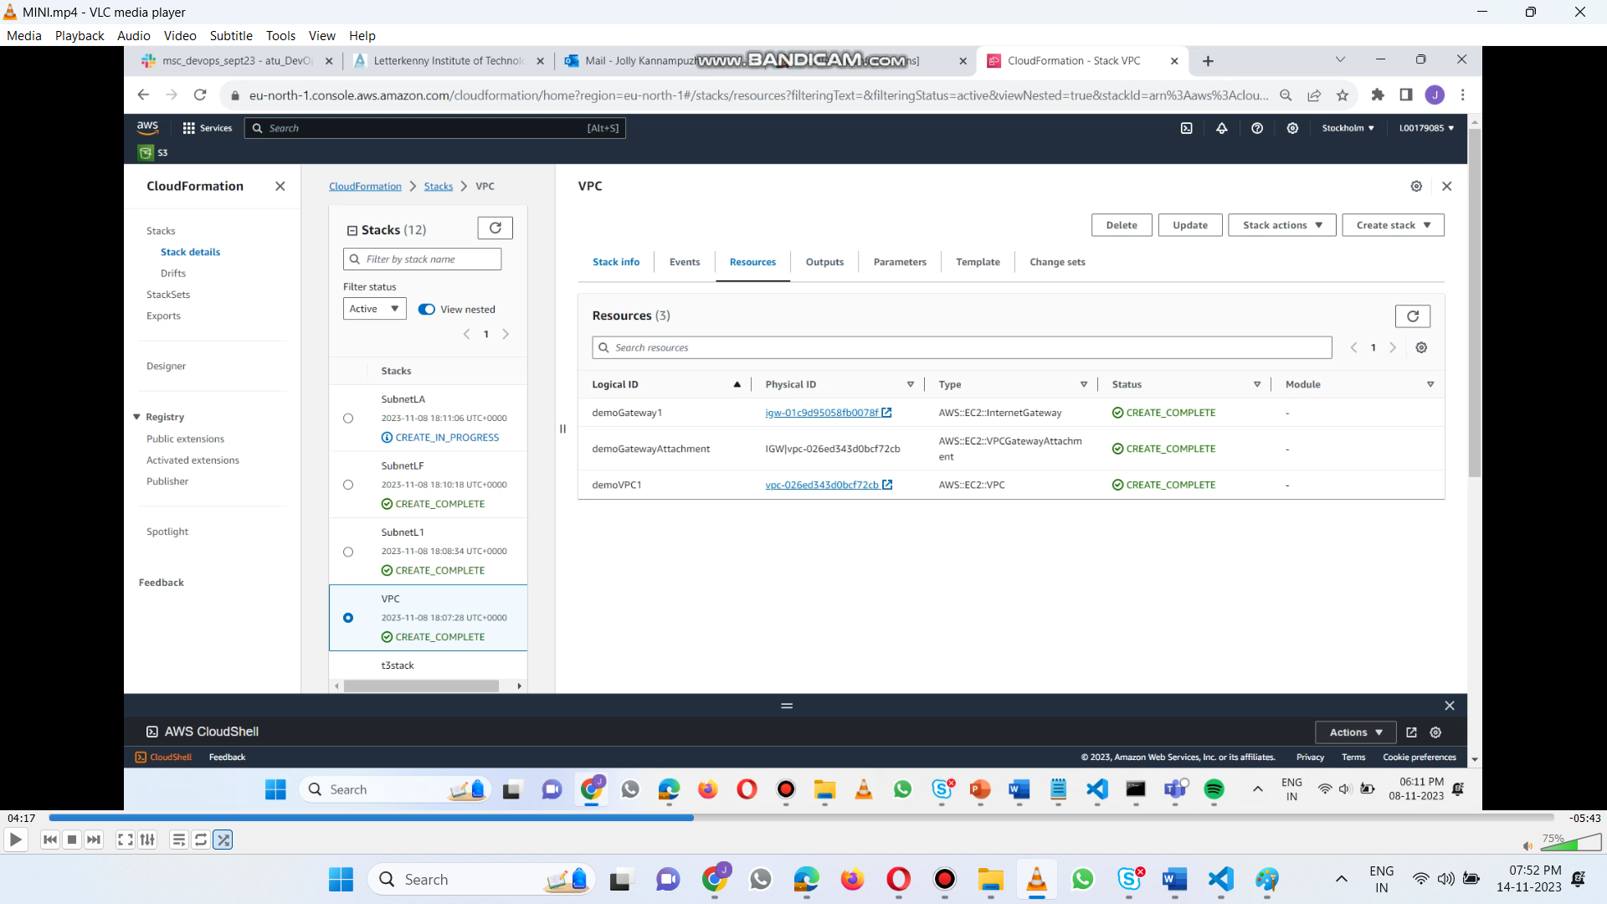

Figure VPC.yml > resources

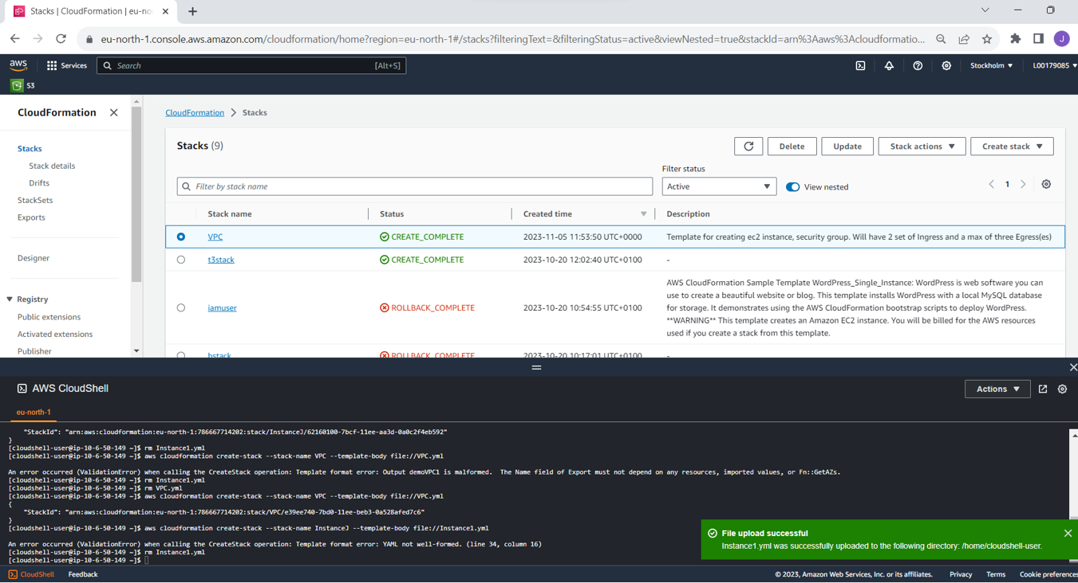

Figure Jump box > Instance1.yml upload

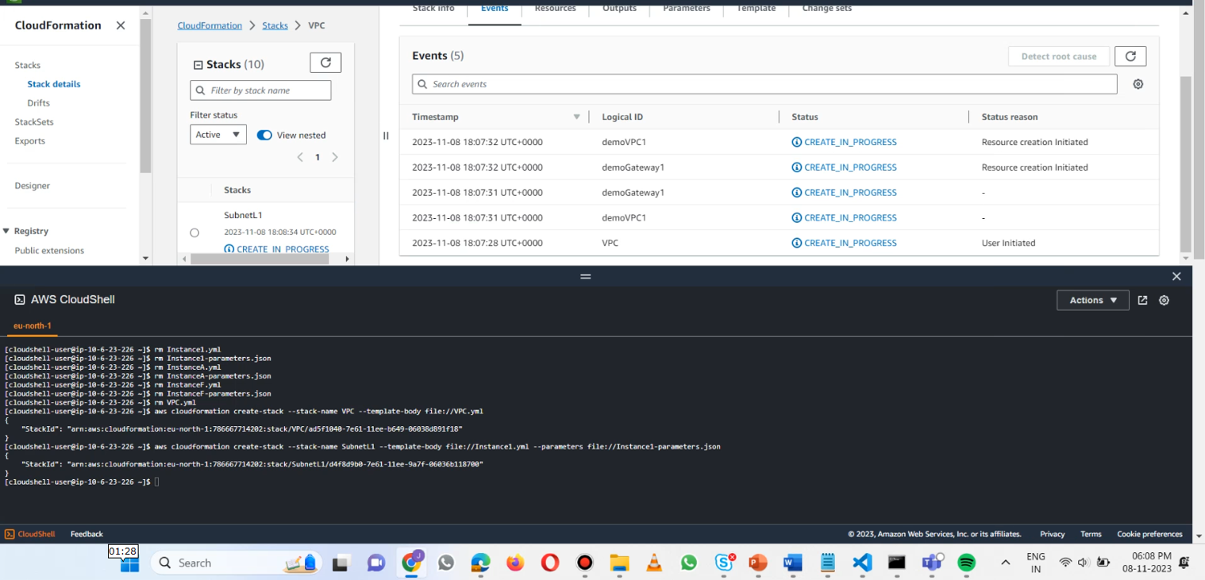

Figure Instance1 > creation

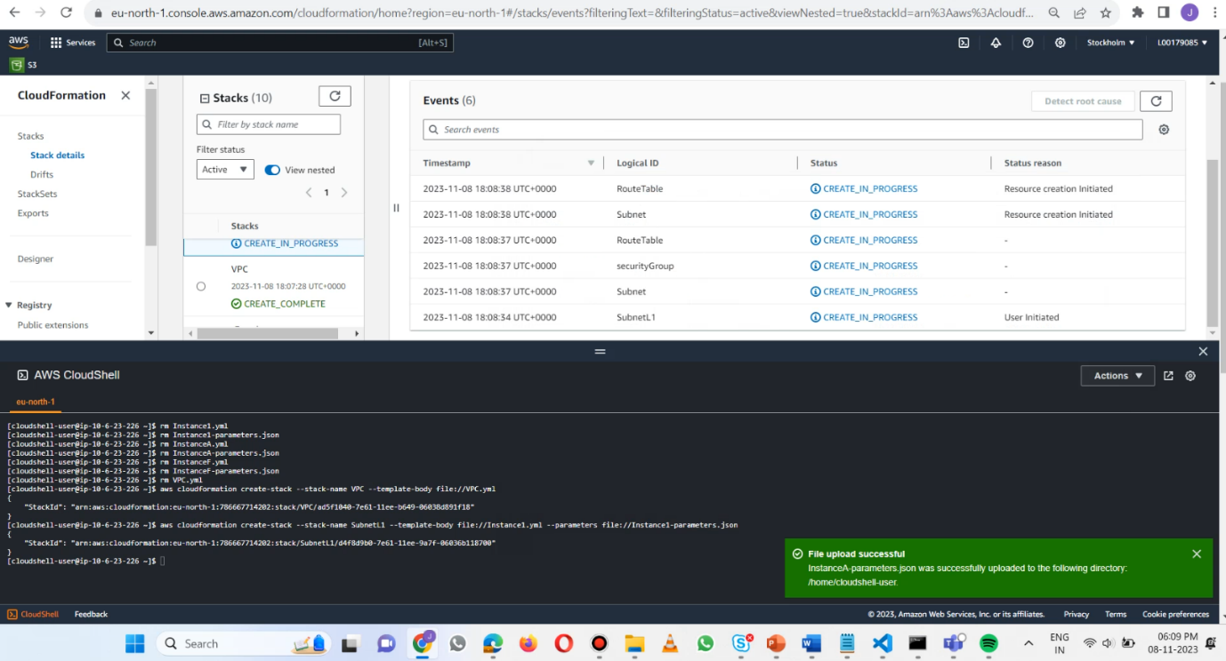

Figure InstanceA > parameters.json uploaded

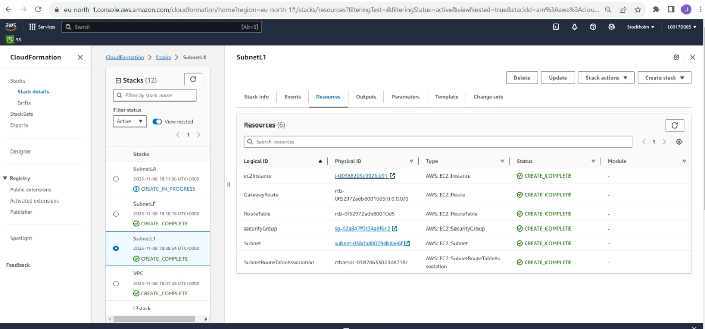

Figure Jump box > Instance1.yml resources

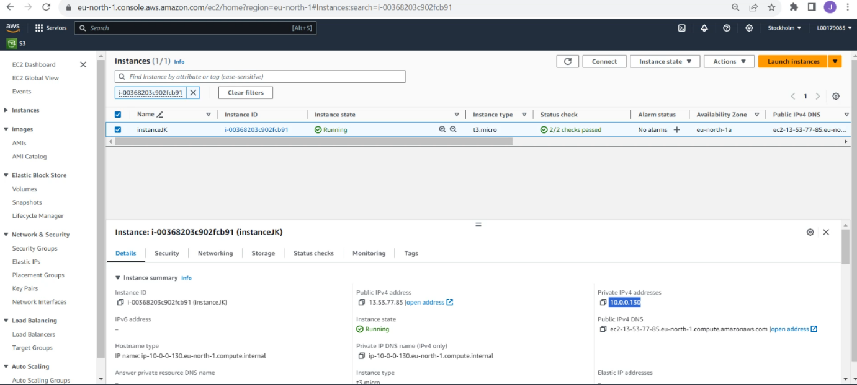

Figure Jump box > Instance1.yml resources – EC2 IP

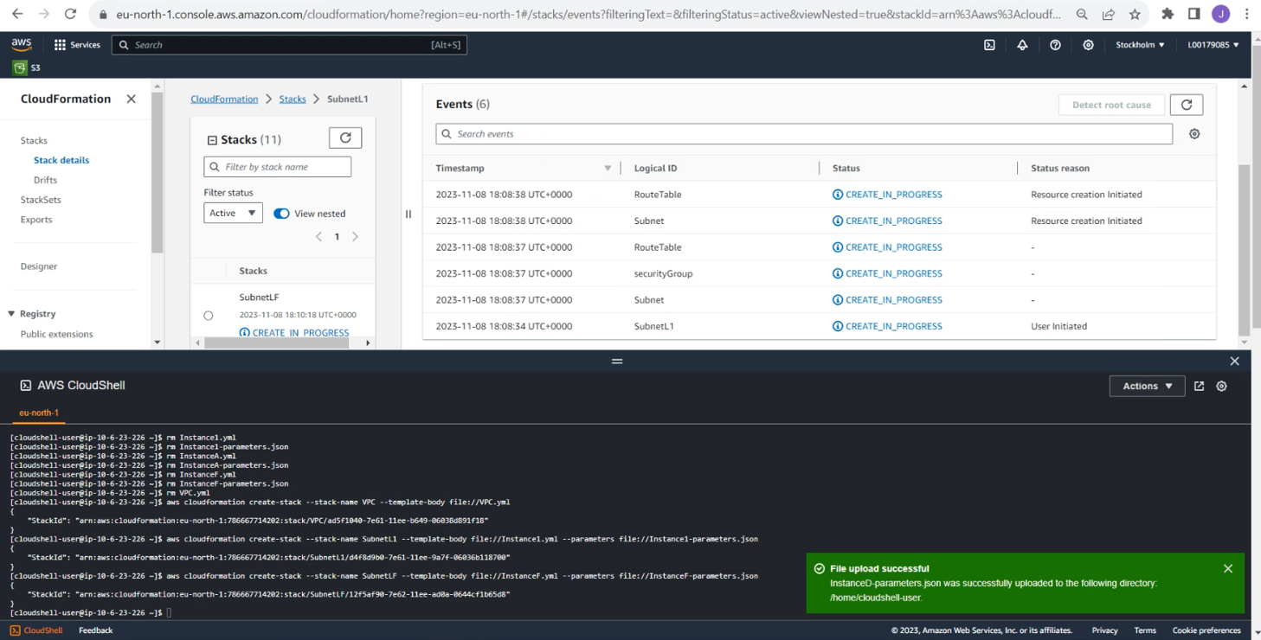

Figure Instance > -parameters.json uploaded

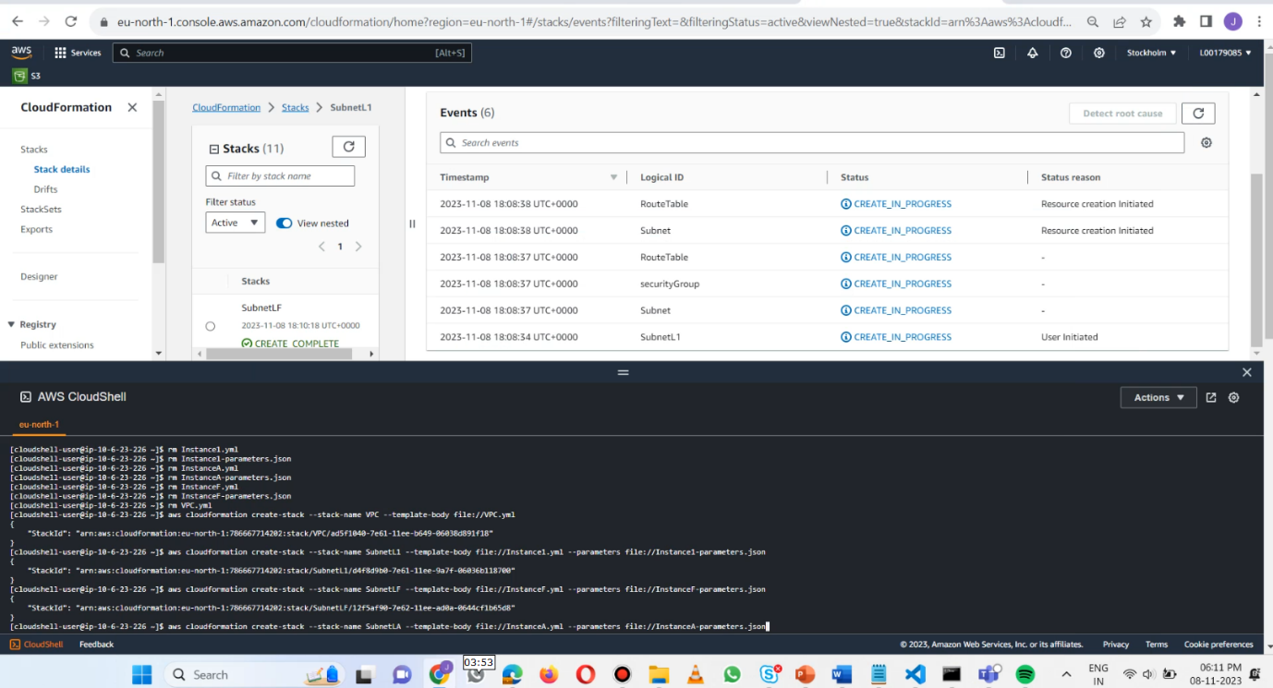

Figure InstanceF > creation

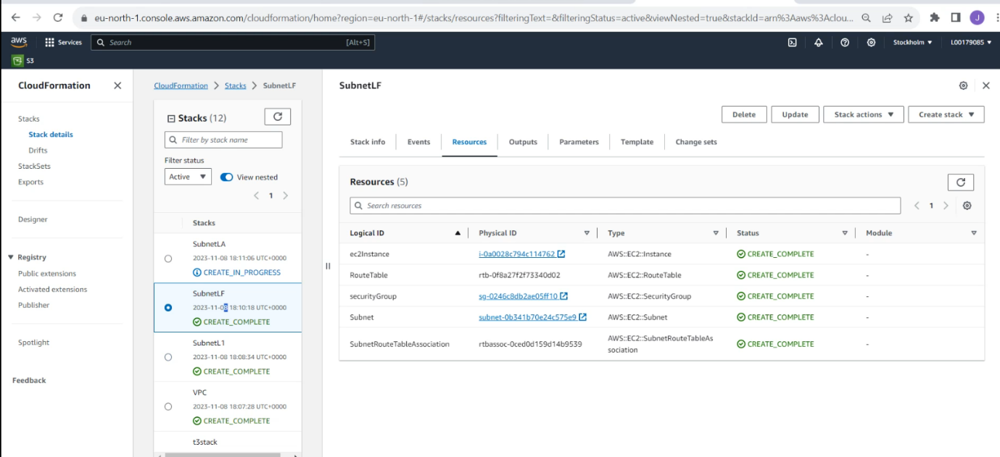

Figure InstanceF > creation – resources

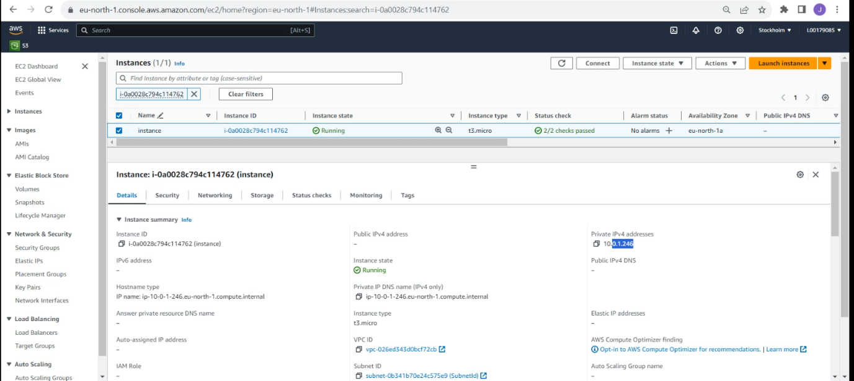

Figure InstanceF > creation – resources - EC2 IP

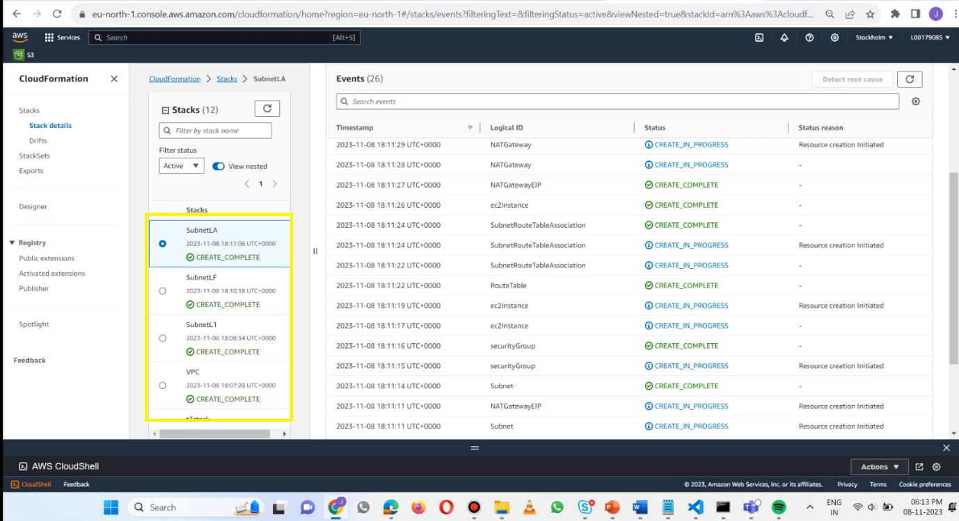

Figure stack creation > Instance VPC, Jump, Web, App, D finally

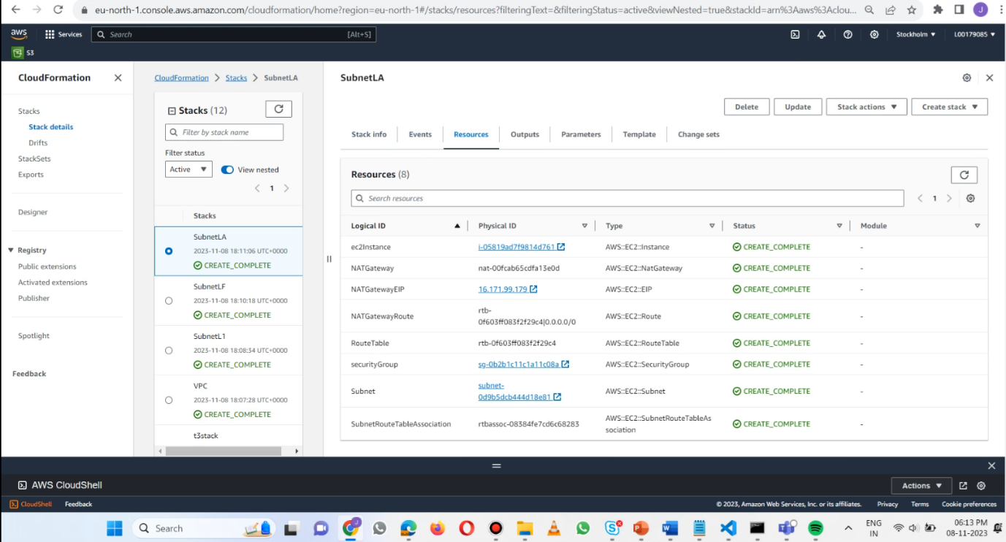

Figure InstanceApp Server > resource tab

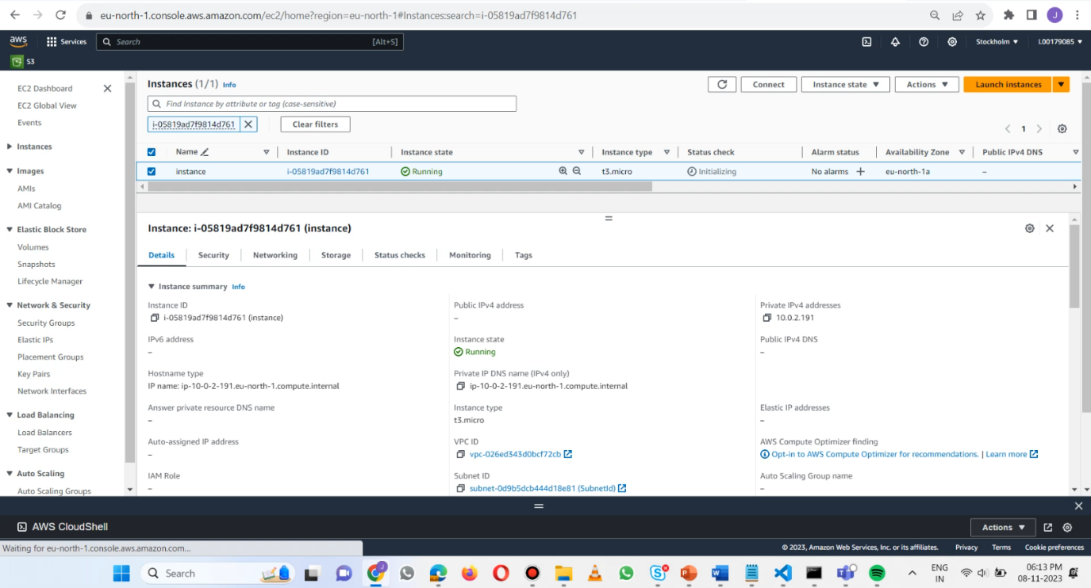

Figure App server > EC2 instance

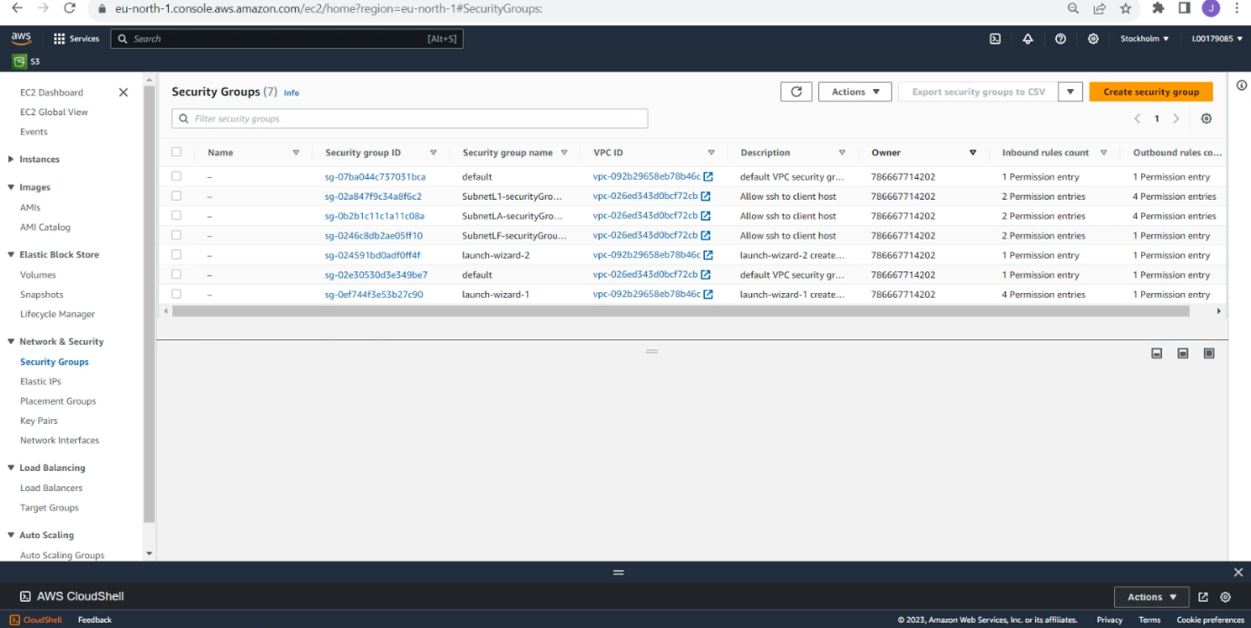

Figure Security Groups > Jump, App, Web

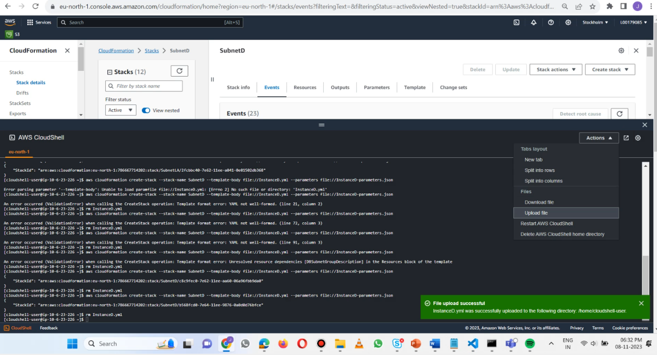

Figure InstanceD > creation

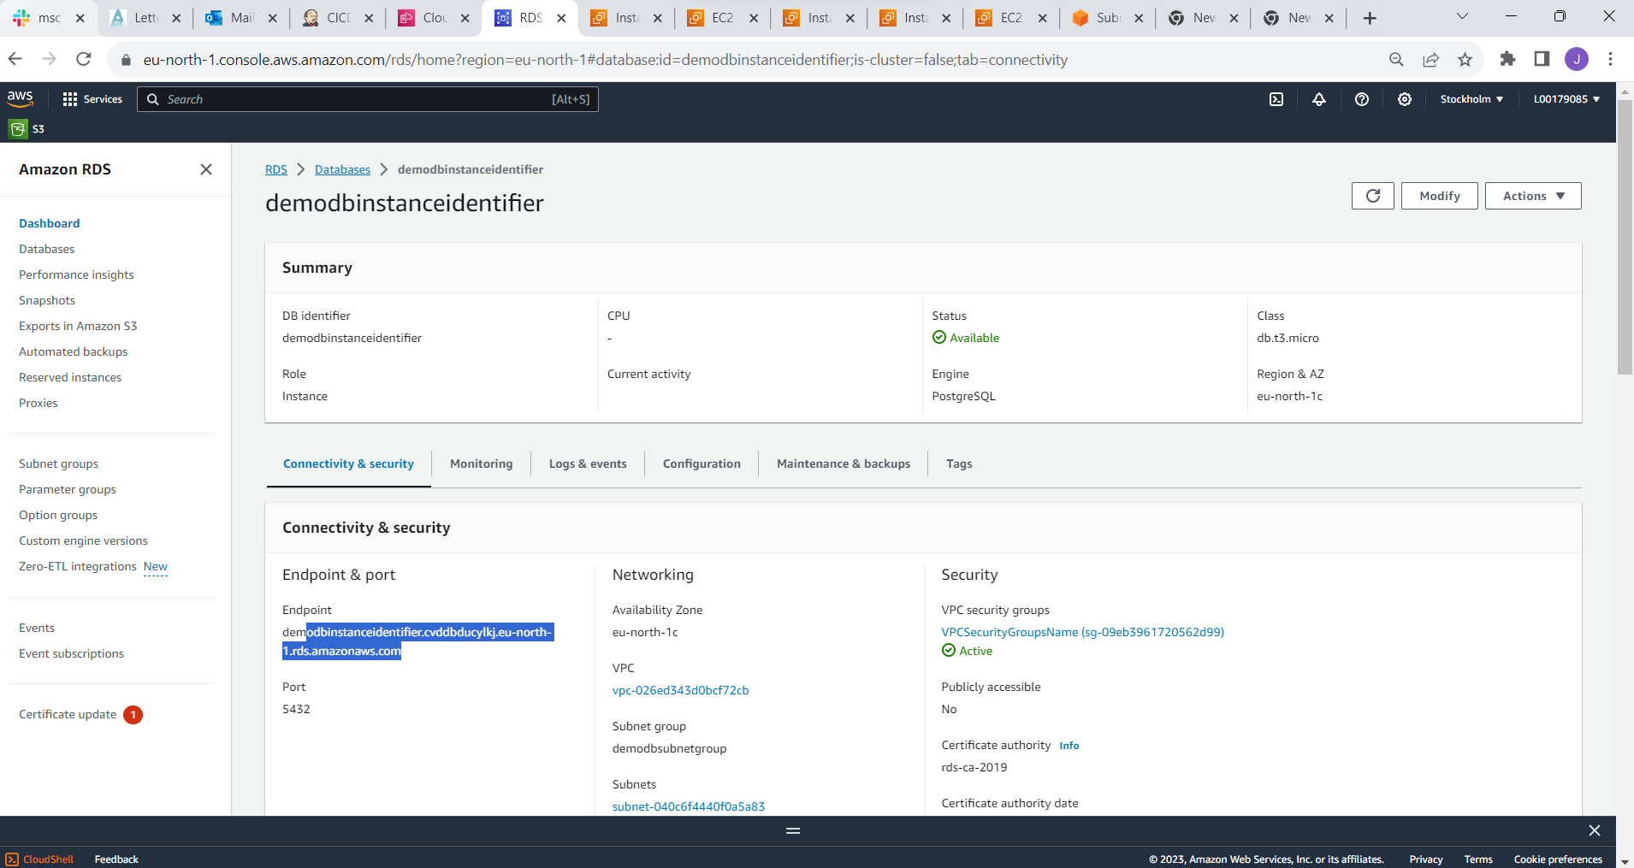

Figure RDS > Endpoint

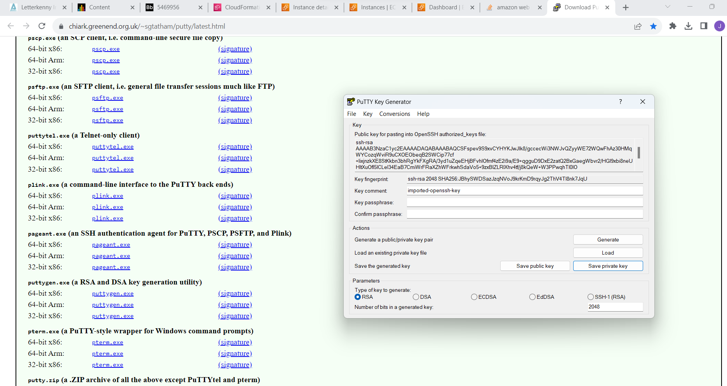

Figure PuTTY > Key generation

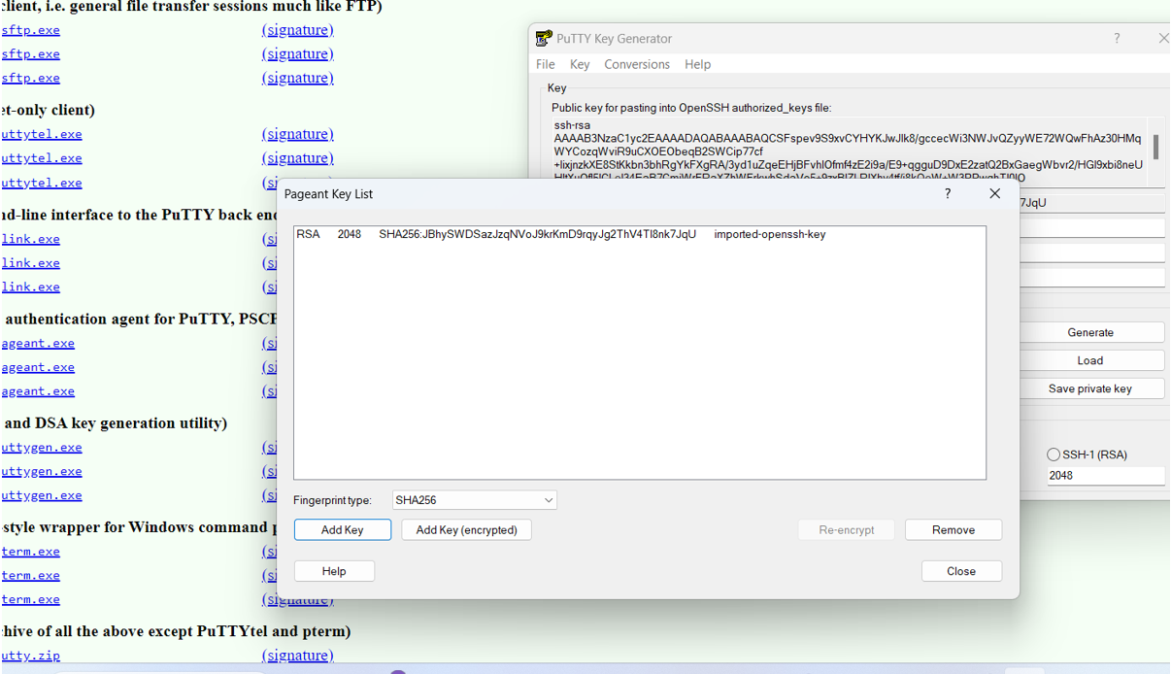

Figure Pageant Key > addition

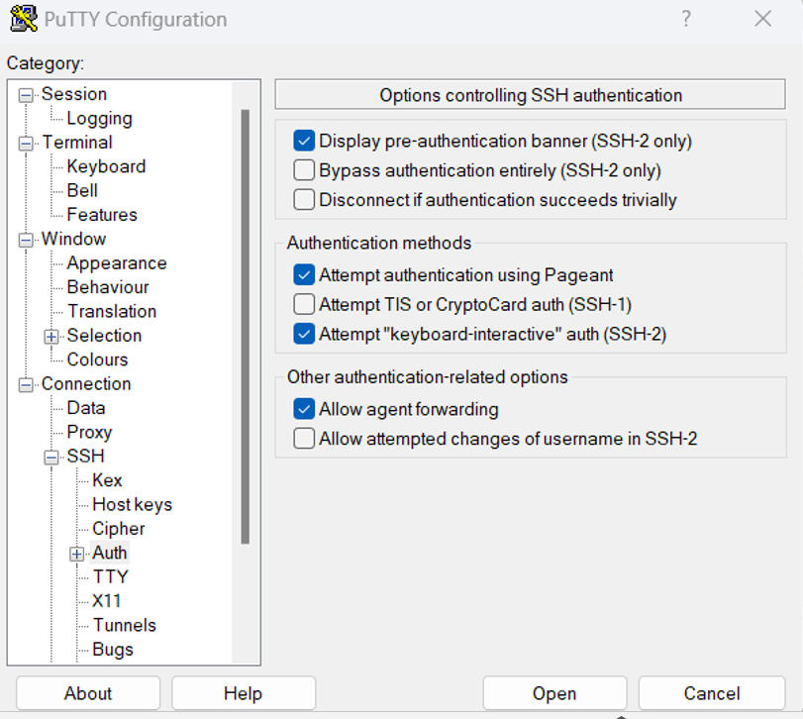

Figure puTTY > Configuartion

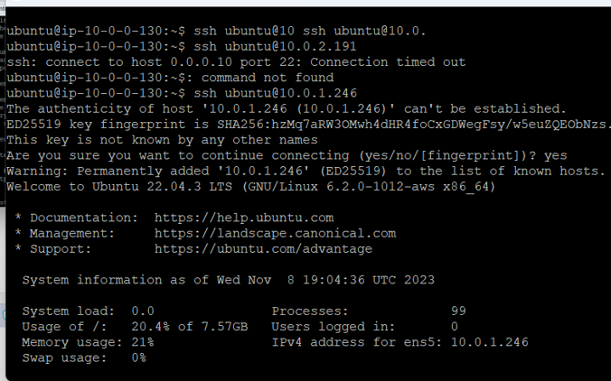  
Figure Jump box access > ssh unbuntu@10.0.0.130 jump box

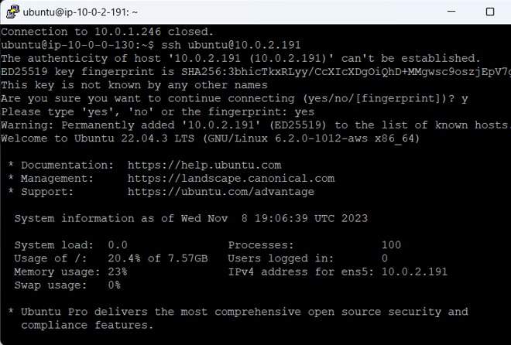

Figure Jump Server > Access App server > ssh unbuntu@10.0.2.191 from 10.0.0.130

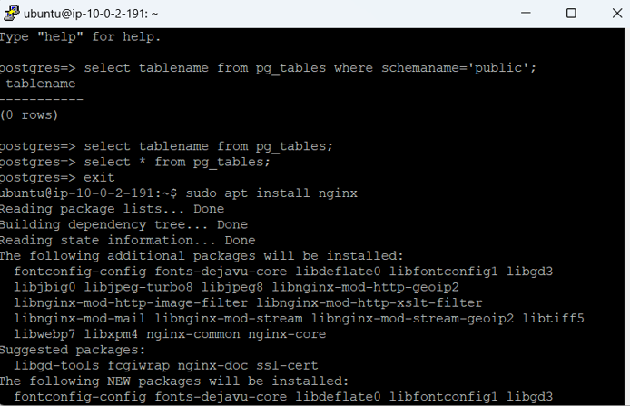

Figure Jump Server > App server - Install nginx @10.0.2.191

|  |
| --- |
| sudo apt update  sudo apt-get install nginx  ubuntu@ip-10-0-2-191:~$ curl http://localhost  ubuntu@ip-10-0-2-191:~$ sudo apt-get install postgresql-client |

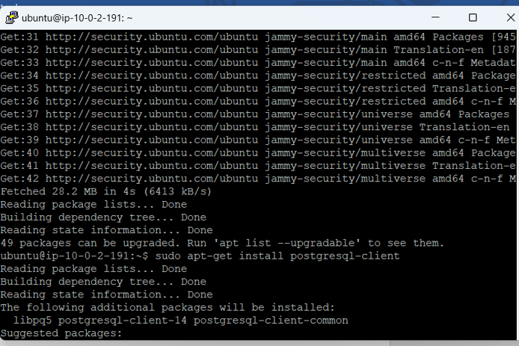

Figure Jump Server > App server - sudo apt-get install postgresql-client installation



Figure RDS - Refer Endpoint from RDS Database

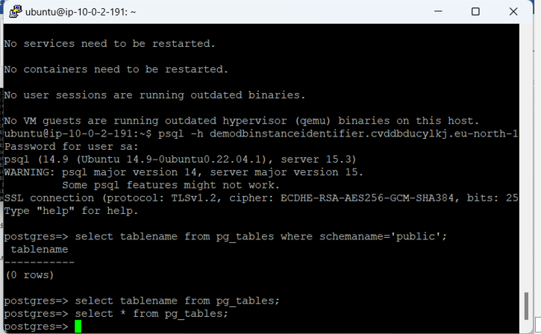

Figure Jump server > App Server - Connect psql

psql -h demodbinstanceidentifier.cvddbducylkj.eu-north-1.rds.amazonaws.com -U sa -d postgres

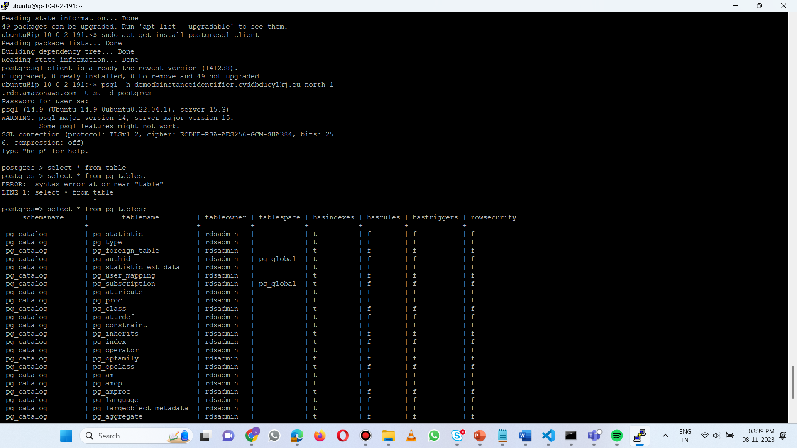

Figure Jump server > App Server - Connect psql >Postgress – access tables – data retrieval

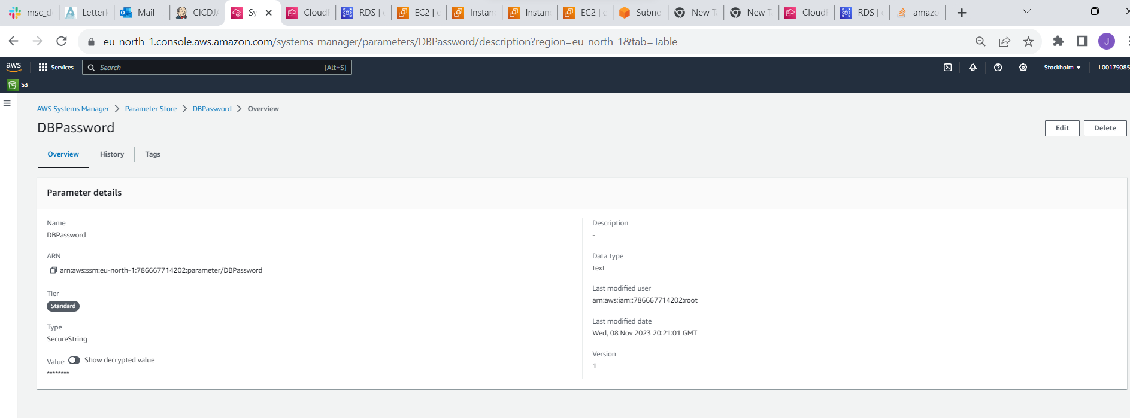

Figure RDS > DBpasspord – AWS Systems manager setupsDBpasspord – AWS Systems manager setups

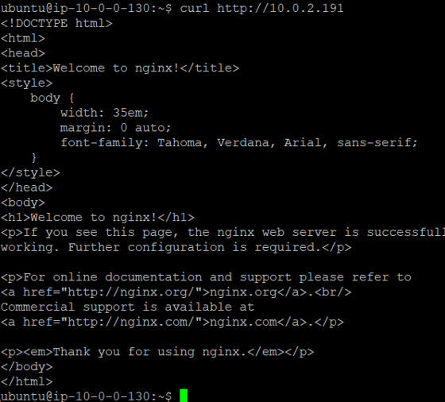

Figure Jump box> Connect application server

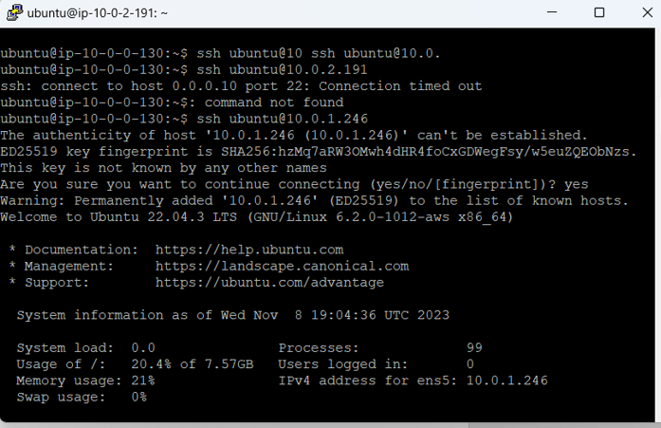

Figure Jump box > Connect Web hosting server

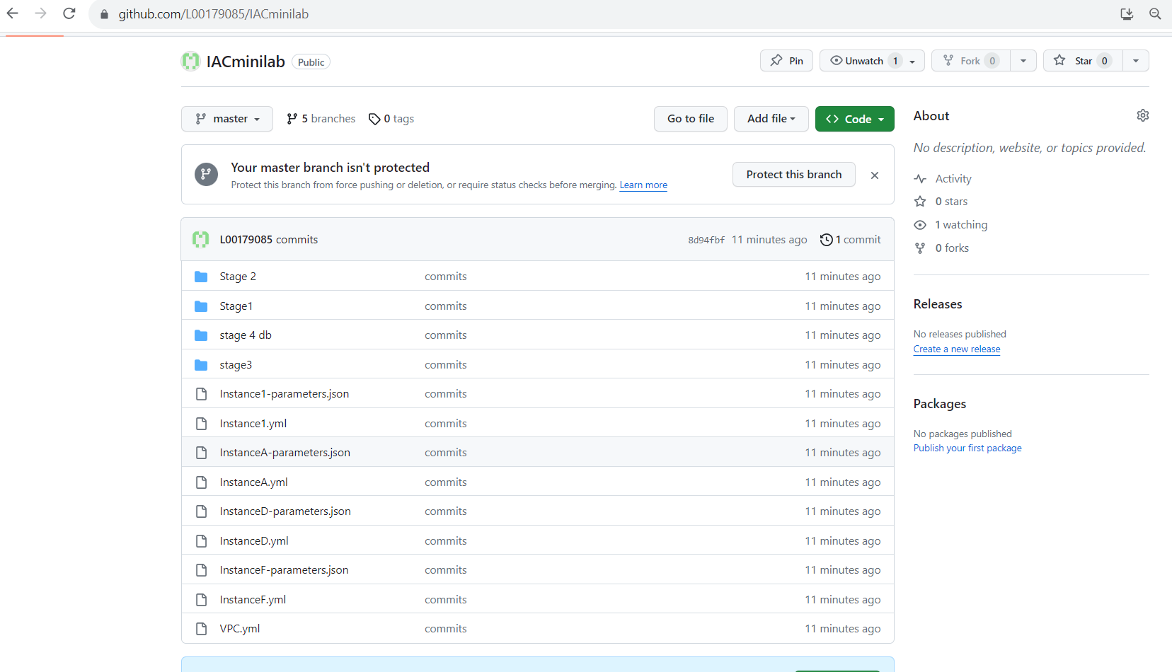

Figure Github > checkins